LINKEDIN AGENT ANALYTICS PLATFORM
Project Documentation

Candidate: Sruthy Babu
Project: LinkedIn Agent Analytics
Repository: github.com/sruthy2488/linkedin-agent-analytics

Table of Contents
Table of Contents 1
1. Project Overview 1
2. Business Objectives 1
3. Technology Stack 1
4. System Architecture 1
5. End-to-End Data Flow 1
6. Source Dataset 1
7. Data Ingestion 1
7.1 Read Source Data 1
7.2 Transform Source Columns 1
7.3 Stable Lead ID 1
8. Data Validation 1
9. Duplicate Detection 1
10. Incremental and Idempotent Loading 1
Processing Logic 1
11. BigQuery Data Warehouse 1
11.1 Staging Table 1
11.2 Fact Table 1
11.3 Analytical Tables 1
12. Star Schema 1
Fact-to-Dimension Relationships 1
13. Star Schema Grain 1
14. Dimension Tables 1
14.1 dim_agent 1
14.2 dim_lead_status 1
14.3 dim_date 1
15. Data Dictionary 1
16. Data Quality Framework 1
17. Composite DQ Score 1
18. Risk Intelligence 1
19. Latest Risk Model Result 1
20. Power BI Dashboard 1
20.1 Page 1 — Lead & Outreach Overview 1
20.2 Page 2 — Agent Analytics & Risk Intelligence 1
20.3 Page 3 — Campaign & Segment Performance 1
21. Power BI Measures 1
22. Data Reconciliation 1
23. Statistical and Business Assumptions 1
24. Testing 1
25. CI/CD 1
26. Dockerisation 1
27. Dependency Management 1
28. Structured Logging 1
29. Alerting 1
Example Failure Flow 1
30. Failure Handling and Recovery 1
31. Idempotent Recovery 1
32. Malformed Input / Dead-Letter Testing 1
33. Security and Configuration 1
34. Database Build and Migration Scripts 1
35. Current Final Validation 1
36. Assessment Deliverables 1
Source Repository 1
Power BI 1
Documentation 1
Part 1 Evidence 1
37. Part 1 Evidence 1
38. Limitations 1
39. Reproduction Instructions 1
40. Conclusion 1

1. Project Overview
The LinkedIn Agent Analytics Platform is an end-to-end data analytics solution designed to transform LinkedIn outreach data into reliable, validated, and actionable business insights.
The platform covers the complete analytical lifecycle:
- Source data ingestion
- Data transformation and standardisation
- Duplicate detection
- Record validation and dead-letter handling
- Incremental and idempotent loading
- BigQuery data warehousing
- Star-schema modelling
- Data quality monitoring
- Statistical risk analysis
- Outreach capacity recommendation
- Power BI reporting
- Docker containerisation
- Automated testing
- CI/CD using GitHub Actions
- Structured logging
- Operational alerting
- Failure and recovery validation
The objective is to provide a reliable analytics layer for monitoring LinkedIn lead generation and outreach performance while identifying operational and account-level risks.

2. Business Objectives
The platform is designed to provide visibility into the following business questions:
- How many leads are currently available?
- How many leads have received invitations?
- What percentage of invitations result in connections?
- What is the reply performance?
- Which lead statuses dominate the pipeline?
- What is the current account health and risk level?
- How much outreach capacity should be recommended?
- Are the underlying data and relationships reliable?
- Can the pipeline safely recover from failures?
- Can invalid source data be identified before entering the analytical warehouse?

3. Technology Stack
Area | Technology
Programming | Python 3.11
Data Processing | Pandas, NumPy
Data Warehouse | Google BigQuery
BI / Reporting | Microsoft Power BI
Query / Analytics | SQL, DAX
Testing | Pytest
Containerisation | Docker
Version Control | Git / GitHub
CI/CD | GitHub Actions
Logging | Structured JSON logging
Alerting | Discord webhook
Configuration | Environment variables / .env

4. System Architecture
The diagram below illustrates the full architecture, from raw data ingestion through to business reporting.
LinkedIn / Polluxa Data Export
↓
Raw CSV Data
↓
Python Ingestion Layer
↓
Transformation |  | Validation |  | Deduplication
↓
Incremental Processing
+ Watermark Logic
↓
BigQuery
↓
Staging Layer  (stg_leads) |  | Warehouse  (fct_leads)
↓
Star Schema
↓
dim_agent |  | dim_lead_status |  | dim_date
↓
fct_leads_star
↓
Risk Model |  | DQ Framework
↓
Power BI
↓
Business Reporting

5. End-to-End Data Flow
The complete data flow is:
Source Export
↓
Raw CSV
↓
Read and Transform
↓
Stable Lead ID Generation
↓
Duplicate Removal
↓
Record Validation
↓
Dead-Letter Separation
↓
Incremental Watermark Filtering
↓
BigQuery Staging
↓
Warehouse Refresh
↓
Star Schema Refresh
↓
Referential Integrity Validation
↓
Data Quality Checks
↓
Risk Model
↓
Power BI

Each pipeline execution receives a unique run ID for traceability.

6. Source Dataset
The current analytical source is a LinkedIn lead export containing 468 records. The dataset contains fields including:
Source Field | Description
Name | Lead name
Job Title | Current job title
Company | Lead's company
Industry | Industry classification
Location | Lead location
Agent | LinkedIn outreach agent
SDR Status | Current lead status
Comment Status | Comment-related status
Hot Score | Lead priority / score
Source | Lead acquisition source
Prioritized | Lead priority indicator
LinkedIn URL | LinkedIn profile URL
Added On | Date/time lead was added
Last Contacted | Last outreach/contact timestamp
Invite Sent At | Timestamp of invitation
Connected At | Timestamp of connection

7. Data Ingestion
The primary ingestion module is:
src/ingest.py

The ingestion process performs the following operations:

7.1 Read Source Data
The pipeline reads the raw LinkedIn lead export.

7.2 Transform Source Columns
Source field names are converted into standardised analytical column names. Example:
Source Column | Standardised Column
Name | name
Job Title | job_title
Company | company
Industry | industry
Agent | agent
SDR Status | sdr_status
LinkedIn URL | linkedin_url
Added On | added_on

Operational fields are also generated:
- staging_id
- record_updated_at
- load_timestamp

7.3 Stable Lead ID
A deterministic identifier is created from the LinkedIn URL. The same LinkedIn URL generates the same identifier across repeated runs. This supports:
- Duplicate detection
- Idempotent processing
- Stable record identification

8. Data Validation
The ingestion layer validates records before warehouse loading. Validation rules include checks for:
- LinkedIn URL
- Staging ID
- Added date
- Required fields
- Basic record consistency

Dead-Letter Handling
Invalid records are separated into a dead-letter dataset rather than silently entering the warehouse.

9. Duplicate Detection
Duplicate leads are removed before loading. The latest successful run produced:
Rows read | 468
Duplicates removed | 0

The final warehouse fact table contained:
Total rows | 468
Unique staging IDs | 468

10. Incremental and Idempotent Loading
The ingestion process uses a watermark to determine which records require processing.

Processing Logic
Previous Watermark
↓
Read Current Source
↓
Identify New / Updated Records
↓
Validate
↓
Load
↓
Update Watermark

A repeated run with no new records does not create additional rows. The latest repeat run produced:
Starting watermark | 2026-09-03 11:47:00+00:00
Previous watermark | 2026-09-03 11:47:00+00:00
Records newer than watermark | 0
Existing records in staging | 468
Final records in staging | 468

Result
This demonstrates idempotent behaviour.

11. BigQuery Data Warehouse
The project uses Google BigQuery as the analytical warehouse.

11.1 Staging Table
Table | Purpose
stg_leads | Stores transformed lead records after ingestion and validation.

11.2 Fact Table
Table | Purpose
fct_leads | Provides the lead-level analytical fact dataset used by downstream analytics.

11.3 Analytical Tables
The pipeline refreshes analytical tables including:
- analytics_lead_funnel
- analytics_lead_status
- analytics_agent_performance
- analytics_risk_scores
These tables are designed for Power BI and analytical consumption.

12. Star Schema
The project implements a dimensional star schema.
Element | Name
Fact Table | fct_leads_star
Dimension | dim_agent
Dimension | dim_lead_status
Dimension | dim_date

Fact-to-Dimension Relationships
dim_agent |  | dim_lead_status |  | dim_date
↓
fct_leads_star
↓
Lead Facts

The fact table contains surrogate keys:
- agent_key
- status_key
- date_key

13. Star Schema Grain
The grain of the fact table is: one row per lead record, identified by its stable staging_id. This means each lead represents one analytical fact record at the lead level.
The latest validation produced:
Fact rows | 468
Unique staging IDs | 468
Orphan agents | 0
Orphan statuses | 0
Orphan dates | 0

Result
Star Schema validation PASSED.

14. Dimension Tables

14.1 dim_agent
Stores agent-level dimension information.
Field | Role
agent_key | Key
agent_name | Business attribute

14.2 dim_lead_status
Stores standardised lead-status members. Current dimension values:
- captured
- connected
- contacted
- invite_sent
- enriched
- linkedin_rate_limited
- replied
Normalization ensures values such as “invite sent” and “invite_sent” are treated consistently.

14.3 dim_date
Stores the date dimension used for time-based analysis.
Field | Role
date_key | Key
full_date | Business attribute

15. Data Dictionary
stg_leads / fct_leads / fct_leads_star
Column | Description | Role
staging_id | Stable lead identifier | Primary / business key
name | Lead name | Attribute
job_title | Job title | Attribute
company | Company | Attribute
industry | Industry | Attribute
location | Lead location | Attribute
agent | Outreach agent | Attribute
sdr_status | Current SDR status | Attribute
comment_status | Comment status | Attribute
hot_score | Lead priority score | Measure / input
source | Lead acquisition source | Attribute
prioritized | Priority indicator | Attribute
linkedin_url | LinkedIn profile URL | Business identifier
added_on | Lead creation timestamp | Date/time
last_contacted | Last contact timestamp | Date/time
invite_sent_at | Invitation timestamp | Date/time
connected_at | Connection timestamp | Date/time
record_updated_at | Source/update timestamp | Operational field
load_timestamp | Pipeline load timestamp | Operational field
agent_key | Agent surrogate key | Foreign key
status_key | Status surrogate key | Foreign key
date_key | Date surrogate key | Foreign key

16. Data Quality Framework
The project implements five primary data-quality dimensions.
Dimension | Description
Completeness | Measures whether required fields are populated.
Uniqueness | Measures duplicate-record violations.
Validity | Measures whether data conforms to expected formats and rules.
Timeliness | Measures whether source data is sufficiently current.
Referential Integrity | Measures whether every fact row can be matched to the corresponding dimension.

17. Composite DQ Score
The individual dimensions are combined into a weighted composite DQ score. The acceptance threshold is 95%.
Latest result:
Dimension | Score
Completeness | 100.00%
Uniqueness | 100.00%
Validity | 93.95%
Timeliness | 100.00%
Referential Integrity | 100.00%
Composite DQ Score | 98.49%
Threshold | 95.00%
Status | PASS

DQ results are stored historically in:
dq_results
This supports monitoring over multiple pipeline executions.

18. Risk Intelligence
The project includes a statistical risk model designed to identify account-level outreach risk. The model considers:
- Connection rate
- Acceptance rate
- Reply rate
- Ghosting rate
- Statistical confidence
- Recommended daily outreach capacity
The model also calculates a lower confidence bound for the connection rate.

19. Latest Risk Model Result
Metric | Value
Agent | Sruthy Babu
Total leads | 468
Connection rate | 24.79%
Acceptance rate | 33.14%
Reply rate | 0.23%
Ghosting rate | 58.00%
95% lower confidence bound | 21.09%
Risk score | 35.00
Risk level | MEDIUM
Recommended daily capacity | 23
Statistical confidence | Adequate for rate monitoring
Model status | STATISTICALLY_ACTIONABLE

The result is stored in:
analytics_risk_scores

20. Power BI Dashboard
The Power BI report contains three pages.

20.1 Page 1 — Lead & Outreach Overview
This page provides the overall view of outreach performance.
KPIs | Visuals
Total Leads Invites Sent Acceptance Rate Reply Rate Connected Leads Conversion Rate Capacity vs Recommended Risk Score Risk Level Ghosting Rate DQ Score | Lead Status Funnel Status Distribution Daily Lead Generation Risk indicators Data Quality indicator

20.2 Page 2 — Agent Analytics & Risk Intelligence
This page focuses on account health and operational risk.
KPIs | Visuals
Total Leads Connected Leads Ghosting Rate Risk Score Recommended Daily Capacity | Agent Performance Account Lead Status Risk Intelligence Risk Outcomes LinkedIn Rate Limited Leads Capacity analysis

20.3 Page 3 — Campaign & Segment Performance
This page analyses lead performance by available source and segment fields.
KPIs | Visuals
Total Leads Invites Connected Leads Acceptance Rate Conversion Rate | Source / campaign performance Industry performance Segment performance Campaign performance table

Note
Because the source data does not provide reliable campaign cost and revenue fields, monetary ROI values are not fabricated.

21. Power BI Measures
The Power BI semantic model uses explicit DAX measures. Examples include:
Measure | Measure
Total Leads | Invites Sent
Acceptance Rate | Reply Rate
Connected Leads | Conversion Rate
Ghosted Leads | Replied Leads
Rate Limited Leads | Rate Limit Rate
Risk Score | Recommended Daily Capacity
DQ Score

This avoids dependence on implicit aggregations and keeps KPI definitions controlled.

22. Data Reconciliation
The Power BI dashboard uses the validated 468-record export loaded into the analytical warehouse. The live Polluxa dashboard may display different figures because it represents a different data snapshot. Therefore:
- Dashboard KPIs are calculated from the validated exported dataset used by the analytics pipeline.
- The project does not hard-code live dashboard counts into Power BI.
- Fields unavailable in the exported dataset are not artificially created.

23. Statistical and Business Assumptions
The risk model assumes that:
- Historical outreach behaviour is useful for estimating current operational risk.
- Connection and reply rates provide meaningful indicators of account health.
- The available sample is sufficiently large for rate monitoring.
- Recommended capacity should remain within the defined daily ceiling.
- Statistical confidence should be considered when interpreting rate-based risk indicators.
The current model reports statistical confidence as “adequate for rate monitoring.” The recommendations should be treated as analytical guidance rather than guaranteed business outcomes.

24. Testing
Automated tests are implemented using Pytest. Test coverage includes:
Area | Coverage
Lead ID | Stable lead ID generation; case-insensitive URL handling; missing URL handling
Validation | Valid records; missing LinkedIn URL; missing staging ID; missing added date
Transformation | Normalized output columns; stable staging IDs; metadata fields
Duplicate removal | Duplicate detection and elimination logic

Run the tests with:
python -m pytest -v
The final test suite passes successfully.

25. CI/CD
GitHub Actions is used for continuous integration.
Git Push / Pull Request
↓
Checkout Repository
↓
Setup Python 3.11
↓
Install Dependencies
↓
Run Pytest
↓
Build Docker Image

Gate
The Docker build is executed only after successful tests. The final CI workflow completed successfully.

26. Dockerisation
The application is containerised using Docker.
Build:
docker build -t linkedin-agent-analytics .

Run:
docker run --rm linkedin-agent-analytics

The Docker configuration:
- Uses Python 3.11
- Installs pinned dependencies
- Copies application source
- Keeps runtime data external
- Uses environment-based configuration
The Docker image was successfully created and validated.

27. Dependency Management
Dependencies are pinned in:
requirements.txt

The project uses pinned versions for reproducible installation. The main dependencies include:
Dependency | Dependency
google-cloud-bigquery | pandas
numpy | db-dtypes
pyarrow | python-dotenv
python-json-logger | pytest

28. Structured Logging
The application uses structured JSON logging. Each pipeline execution is assigned a unique run ID. Example:
run_id = 12d7547b-e686-4045-8528-eebf255c6fca

The run ID provides correlation across pipeline events. Structured logging makes logs easier to search and process by monitoring tools.

29. Alerting
Operational alerts are implemented for important pipeline events. Supported alert scenarios include:
- Pipeline failure
- Data quality threshold breach
- Abnormally long execution duration

Example Failure Flow
Pipeline Error
↓
Structured Log
↓
Failure Alert
↓
Pipeline Run Recorded as FAILED

30. Failure Handling and Recovery
A controlled star-schema failure occurred during validation when fact-table status values were not fully represented in the status dimension. The pipeline correctly detected:
Check | Before Fix | After Fix
Missing agent keys | 0 | 0
Missing status keys | 319 | 0
Missing date keys | 0 | 0

The pipeline then:
- Detected the referential-integrity failure.
- Raised an exception.
- Sent a pipeline_failure alert.
- Recorded the run as FAILED.
The status dimension was corrected and the pipeline was rerun.

Recovery Result
Composite DQ Score: 98.49% — DQ Status: PASS — Pipeline run: SUCCESS. Star Schema validation PASSED.

31. Idempotent Recovery
After recovery, the pipeline was executed again using the existing watermark. Result:
Records newer than watermark | 0
Existing records in staging | 468
Final records in staging | 468

This confirms that recovery did not create duplicate fact records.

32. Malformed Input / Dead-Letter Testing
A controlled malformed-input test was performed against a temporary copy of the source dataset. One record was created with a missing LinkedIn URL. The validation result was:
Valid records | 468
Dead-letter records | 1
Error identified | Missing linkedin_url

The invalid record was isolated and the original source dataset remained unchanged. This demonstrates that malformed records can be caught before entering the analytical warehouse.

33. Security and Configuration
Environment-specific values are kept outside source control. A local .env file can contain:
GCP_PROJECT_ID=your_project_id
BQ_DATASET=linkedin_agent_analytics
API_URL=your_api_url
API_TOKEN=your_api_token
ALERT_ENABLED=true
ALERT_WEBHOOK_URL=your_webhook_url
MAX_RUN_DURATION_SECONDS=300
FULL_REFRESH=false

Security Note
Sensitive values should never be committed to GitHub. The repository contains .env.example rather than actual credentials.

34. Database Build and Migration Scripts
Database creation and warehouse-building logic is implemented through Python/BigQuery scripts under:
src/

Relevant scripts include:
Script | Supports
create_dimensions.py | Dimension creation
create_star_analytics.py | Star-schema creation
refresh_warehouse.py | Fact-table construction / analytical-table refresh
refresh_star_schema.py | Star-schema refresh
fix_dim_agent.py | Dimension-key validation
fix_status_dimension.py | Referential-integrity validation

35. Current Final Validation
The final successful pipeline run produced the following state:
Metric | Value
Source rows | 468
Duplicates removed | 0
Valid records | 468
Dead-letter records | 0
New records on repeat run | 0
Fact rows | 468
Unique staging IDs | 468
Missing agent keys | 0
Missing status keys | 0
Missing date keys | 0
Composite DQ score | 98.49%
DQ threshold | 95.00%
DQ status | PASS
Risk score | 35.00
Risk level | MEDIUM
Recommended capacity | 23
Pipeline status | SUCCESS

36. Assessment Deliverables
The final submission contains the following:

Source Repository
GitHub repository containing:
- Complete Python source code
- Tests
- Dockerfile
- Requirements
- CI/CD workflow
- README
- Database build scripts
- Configuration template

Power BI
- .pbix Power BI file
- PDF export
- Screenshots of all three dashboard pages
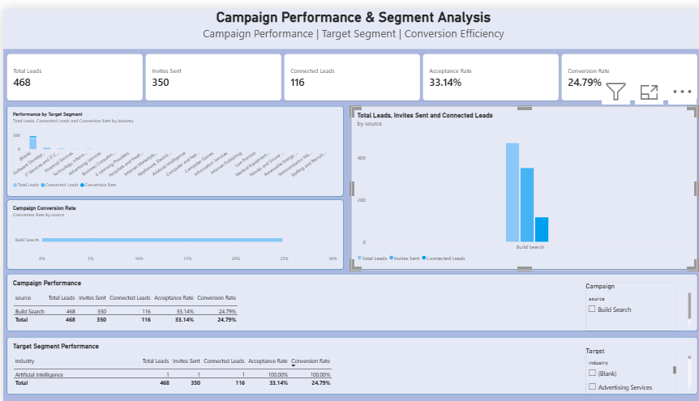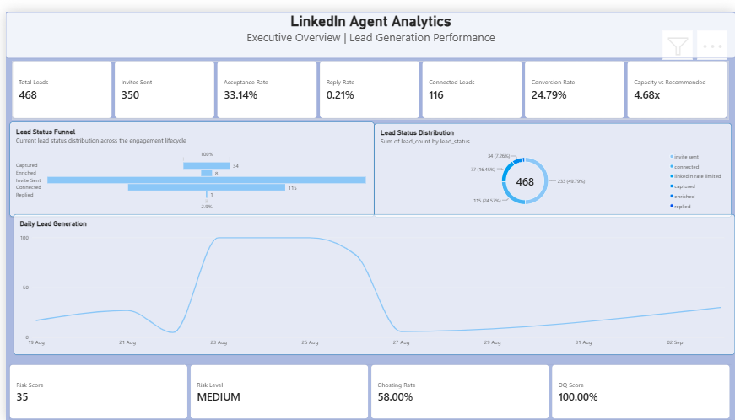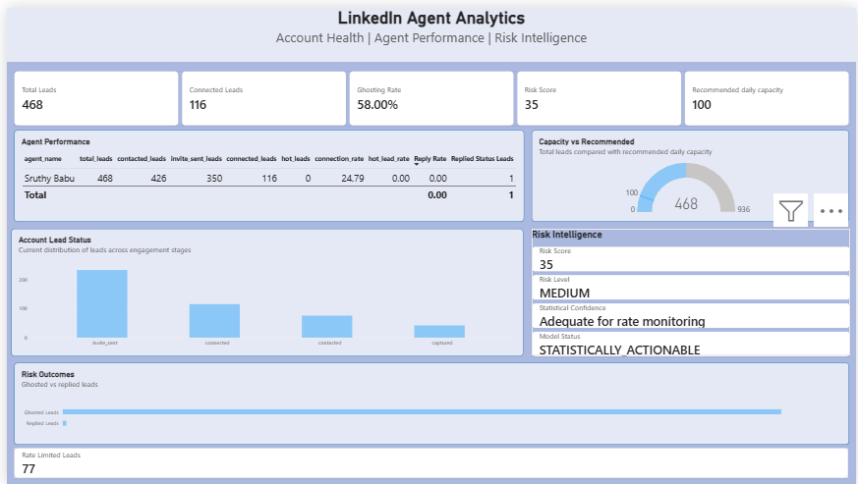

Documentation
- Architecture
- Data flow
- Database/star schema
- Data dictionary
- Data quality framework
- Risk-model explanation
- Operational and CI/CD documentation

Part 1 Evidence
- Seven-step integration screenshots
- Declared Account Age tier

37. Part 1 Evidence
The Part 1 evidence pack documents the seven-step LinkedIn integration process and supporting screenshots.
Item | Value
Declared Account Age Tier | 1+year

38. Limitations
The following limitations apply to the current implementation:
- The analytical dataset is an exported snapshot and may not exactly match the live application at the same time.
- Monetary campaign cost and revenue data is not available, so monetary ROI is not calculated.
- Risk recommendations are based on available historical outreach behaviour and should be interpreted as analytical guidance.
- LinkedIn operational limits and platform behaviour may change independently of the analytical model.
- The current solution is designed around the provided assessment dataset and configuration.

39. Reproduction Instructions
Clone the repository:
git clone https://github.com/sruthy2488/linkedin-agent-analytics.git
cd linkedin-agent-analytics

Install dependencies:
pip install -r requirements.txt

Configure environment variables using:
.env.example

Authenticate to Google Cloud with appropriate BigQuery access.

Run the pipeline:
python src/ingest.py

Run tests:
python -m pytest -v

Build Docker image:
docker build -t linkedin-agent-analytics .

40. Conclusion
The LinkedIn Agent Analytics Platform provides a complete analytical workflow from source ingestion to business intelligence reporting. The final implementation demonstrates:
- Reliable data ingestion
- Incremental processing
- Idempotent loading
- Duplicate prevention
- Data validation
- Dead-letter handling
- BigQuery warehousing
- Star-schema modelling
- Referential-integrity validation
- Data quality monitoring
- Statistical risk intelligence
- Capacity recommendation
- Power BI reporting
- Automated testing
- Dockerisation
- CI/CD
- Structured logging
- Operational alerting
- Failure detection
- Recovery without duplication

Final Result
The final validated pipeline achieved a 98.49% composite data-quality score, passed star-schema integrity checks, completed risk analysis successfully, and demonstrated successful recovery without duplicate records.

Repository
https://github.com/sruthy2488/linkedin-agent-analytics
Candidate
Sruthy Babu — Data Science | Data Analytics

